**Learning Outcomes**

1. Performing CRUD operations using HTTP Rest
2. Inventory Client

**Inventory Client**

Let’s make a simple inventory client using inventory backend.

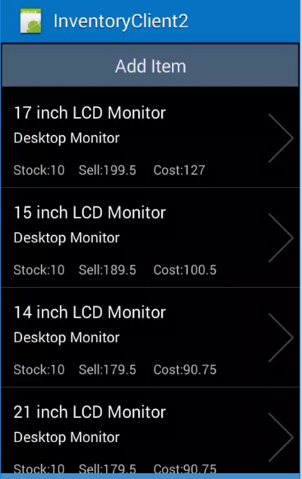 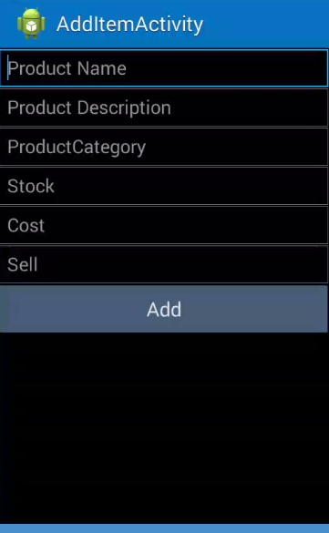

**Main.axml AddItem.axml**

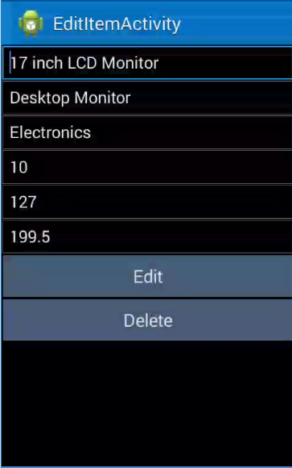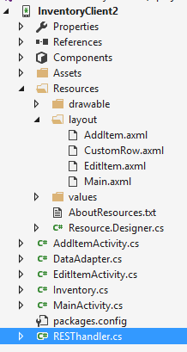

**EditItem.axml**

Go to your API, copy your response and convert it into C# (JSON to C#)

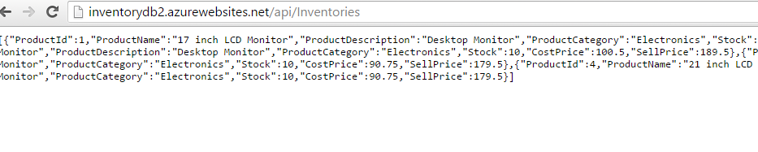

You should probably get a class as shown below

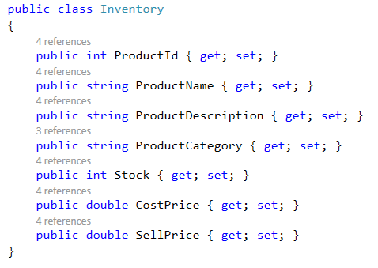

**RestHandler.cs**

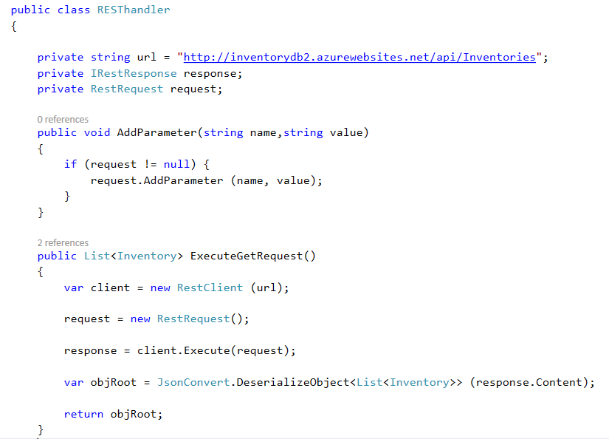

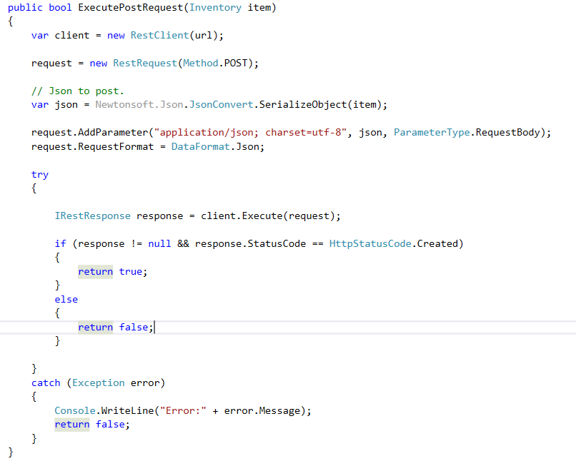

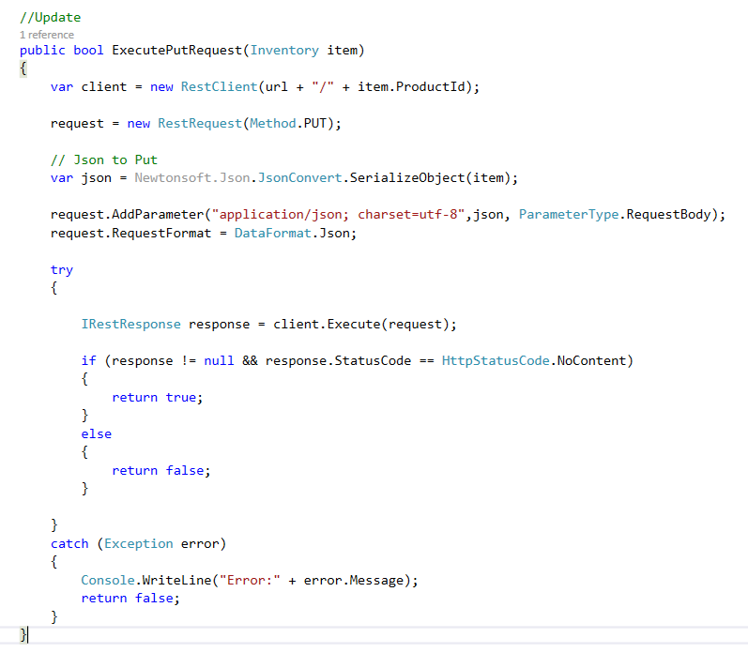

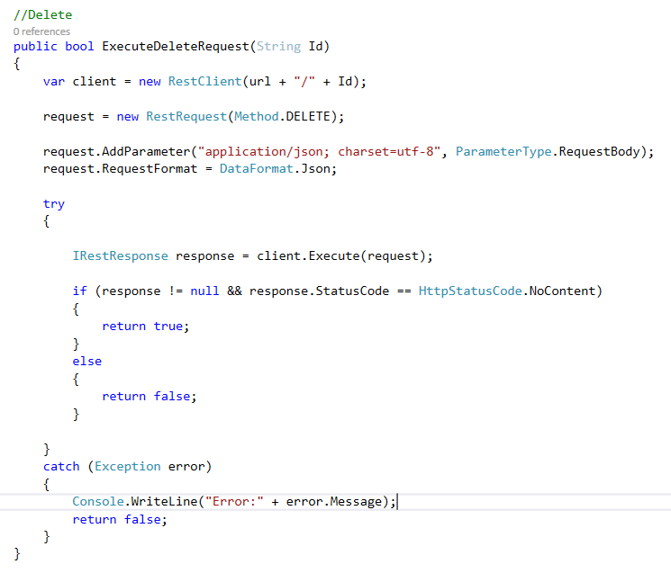

**MainActivity.cs**

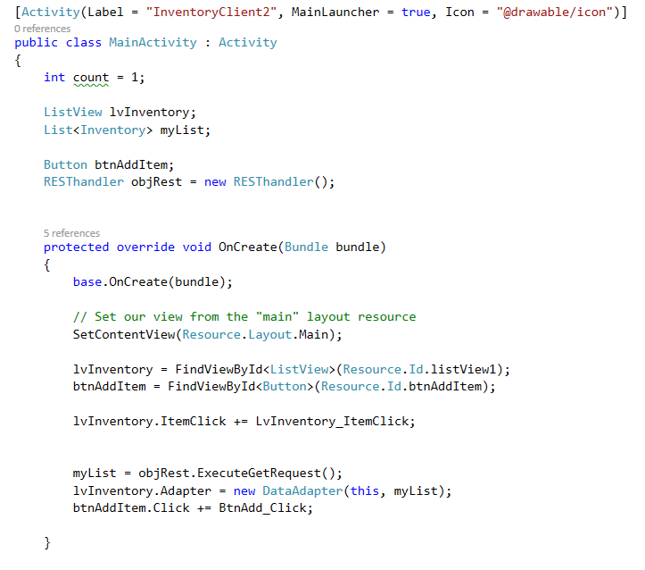

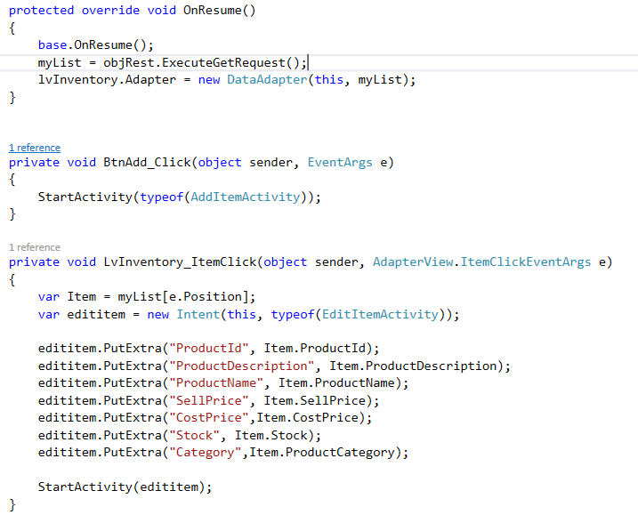

**EditItemActivity.cs**

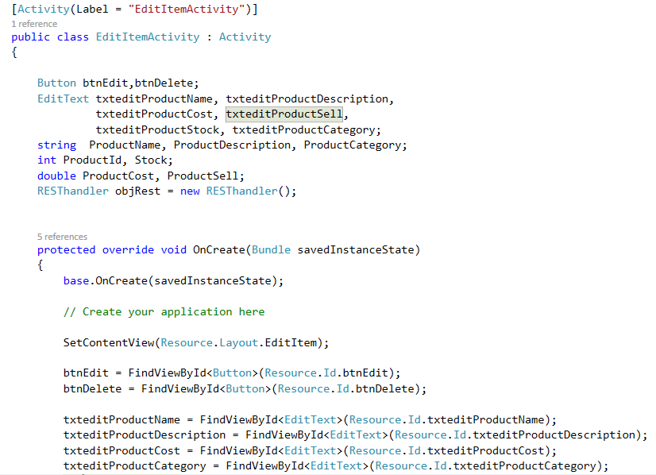

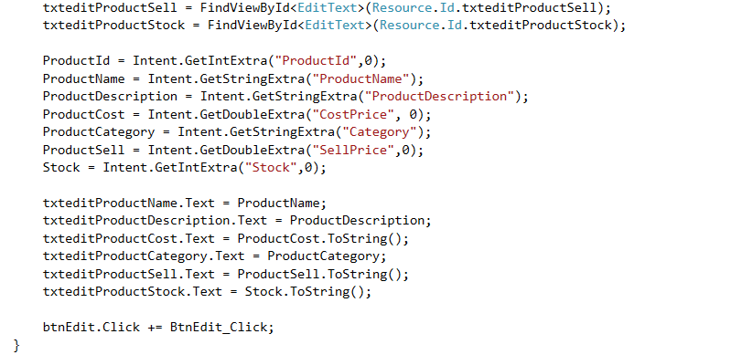

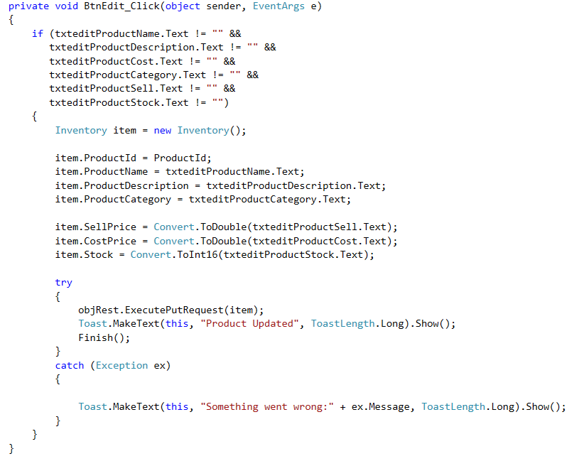

**AddItemActivity.cs**

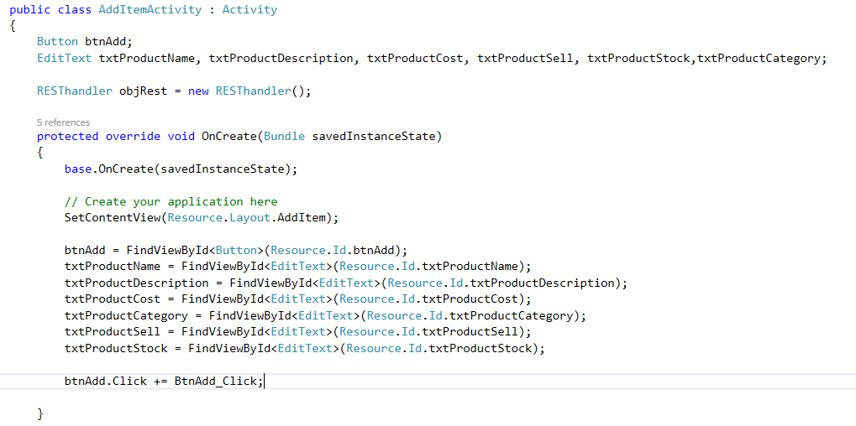

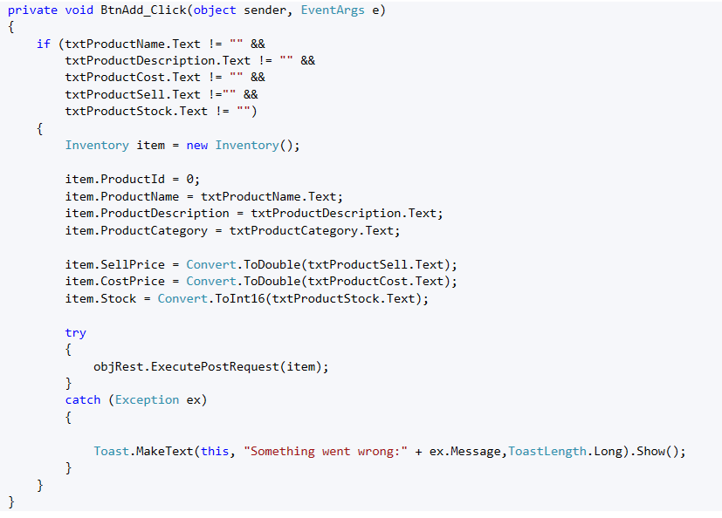

**Dataadapter.cs**

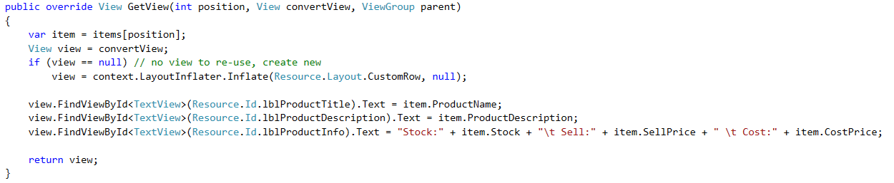

**Exercise**

1. Complete the delete button click in EditItemActivity
2. Create another layout for processing orders and write the code for it to flow to the Orders API that you completed yesterday.